Downloadable graphics are square sized for use on various social media channels and can display on Instagram, Facebook, or Twitter. We encourage you to make the post your own, but here are some ways to really make it great!
- Tag @TeensDriverSeat on social media to receive All-Star points. Channel must be public and we should be able to tell what school it is for us to count the post.
- If you write your own posts, please use #ridewithme to identify posts.
- Add your organization logo to the graphics
- Encourage a student to post an Instagram Live interview on the topic
- Host an Ask Me Anything Instagram Story after posting the graphics
- Use the graphics to build out a blog post for your website

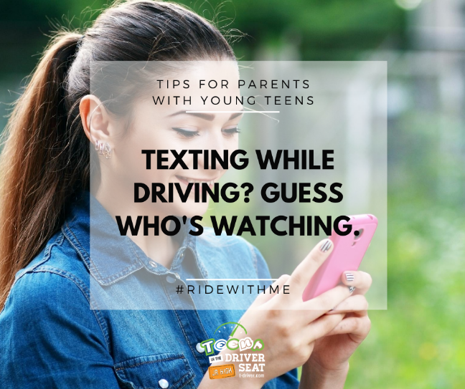
Don't talk - show. #ridewithme @teensdriverseat

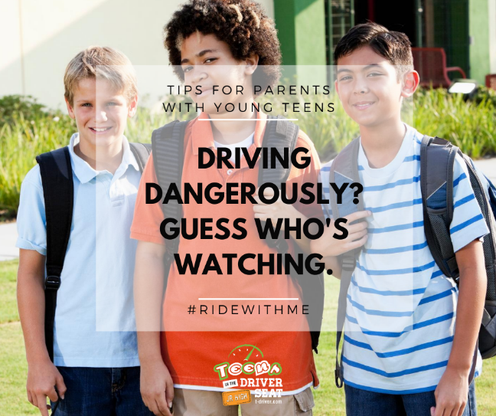
You may not be thinking about them driving, but they already are. Make every trip a lesson in safe driving. #ridewithme @teensdriverseat

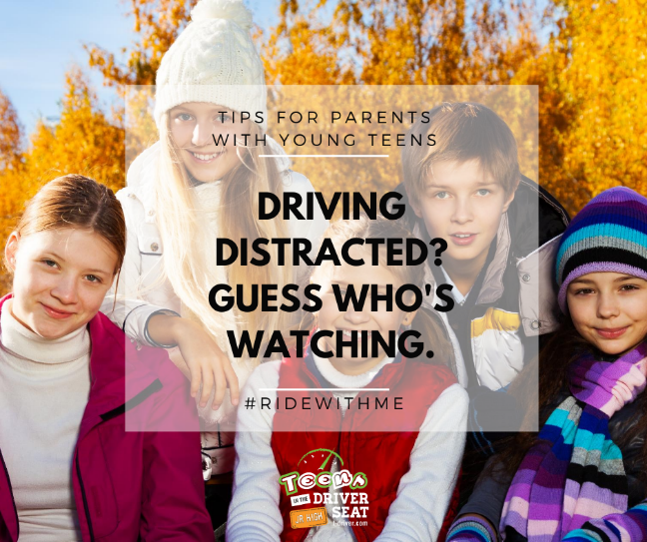
Every move you make - they'll be watching you. 👀 Make every trip a lesson in safe driving. #ridewithme @teensdriverseat

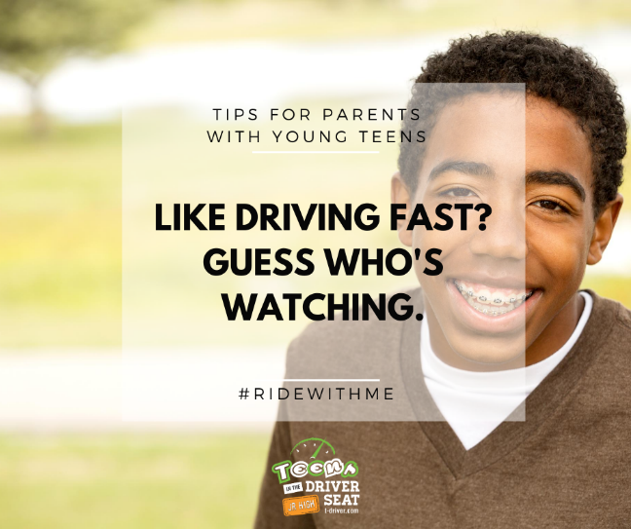
One day they'll say they drive like you. Make every trip a lesson in safe driving. #ridewithme @teensdriverseat

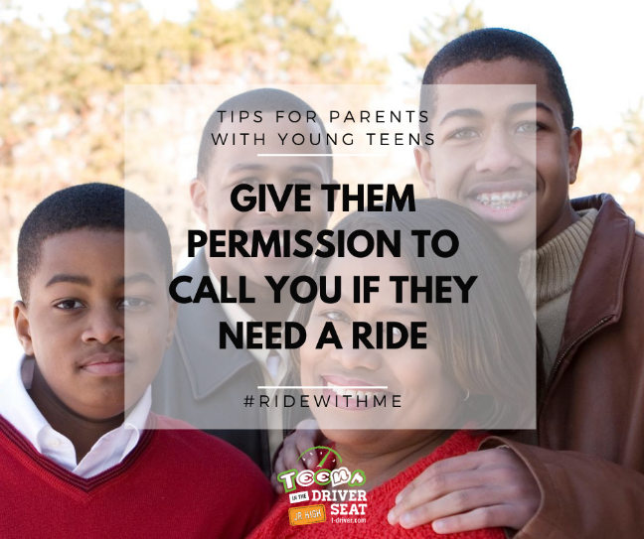
Dangerous situations come at all ages. Let your young teen know they have an out by calling you for a ride. #ridewithme @teensdriverseat

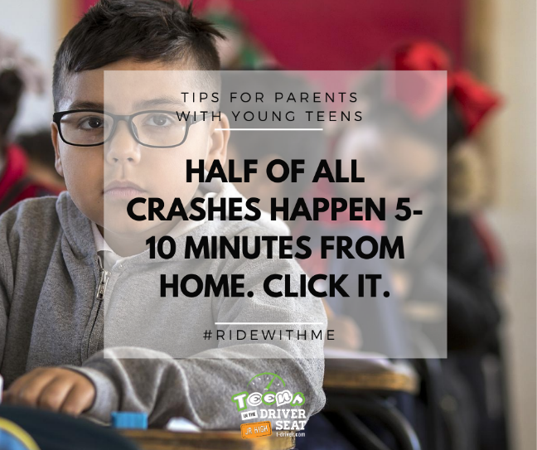
Every trip, every seat. Click = I love you. #ridewithme @teensdriverseat

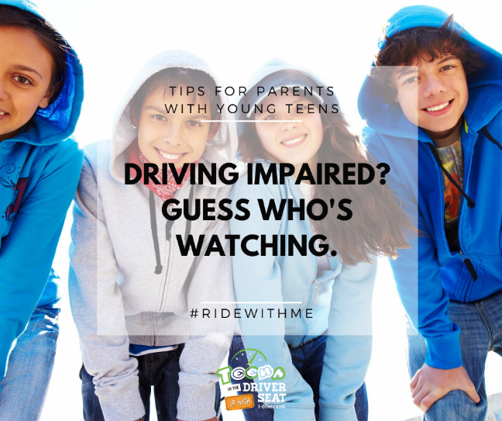
Let them know it's not okay by setting the example. #ridewithme @teensdriverseat

Young teens are more secure in back seats. If their knees do not bend over the back seat edge or the seat belt does not fit well, they also need a booster. Learn more about passenger seat belt safety> https://www.t-driver.com/know-the-risks/junior-high-2/always-seat-belt/ #ridewithme @teensdriverseat

Young teens fit more securely in the back seat, making it the safest spot in case of a crash. #ridewithme

Buckle up for them and they will buckle up for you. #ridewithme @teensdriverseat

Make 'Click' your teen's love language. #ridewithme @teensdriverseat

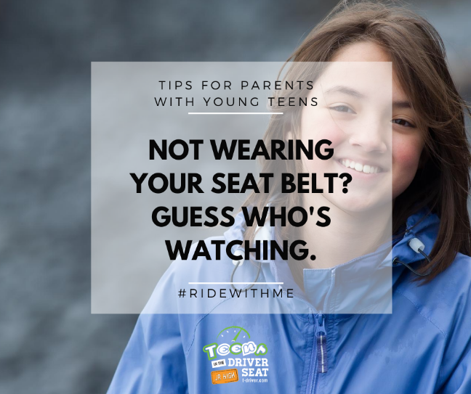
A seat belt is their best and last protection in case of a crash. It's also yours. Make every trip a lesson in safe driving. #ridewithme

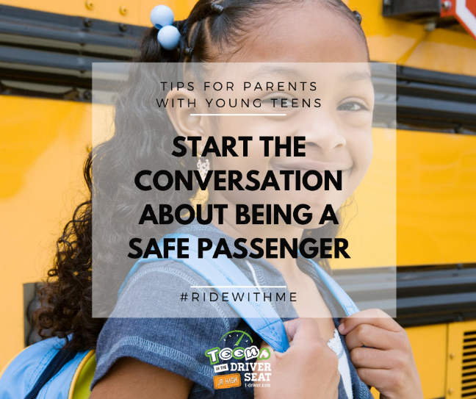
Passengers can contribute to traffic safety. Buckling up, not distracting the driver, and speaking up when they see danger are within their power. #ridewithme @teensdriverseat

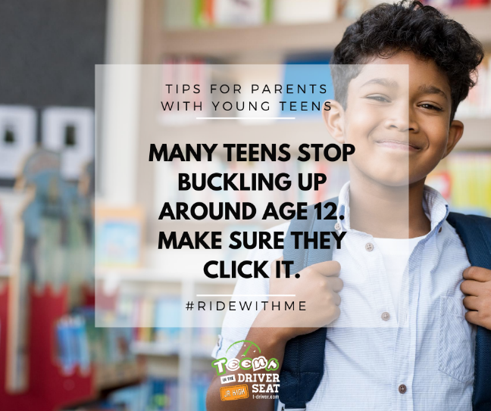
Keep listening for that click. #ridewithme @teensdriverseat

